From Jerusalem Post July 2009

From the sands of Gush Katif to the rolling hills of Lachish

Gaza evacuee Rachel Saperstein is spending her time on developing the new community for evacuees currently under construction in the Lachish region.
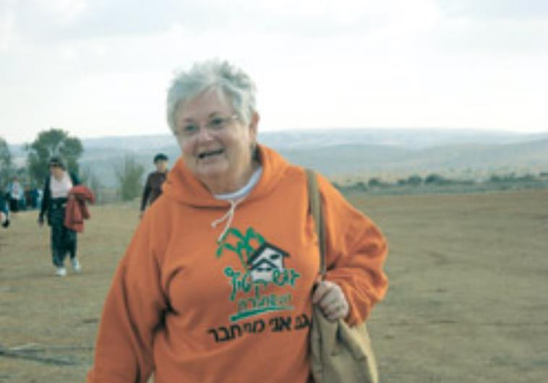
(photo credit:Ann Goldberg)
Most 68-year-old women, if they're not already retired, are at least thinking of doing so. But not Rachel Saperstein - she still has far too much work to do.
Saperstein and her husband, Moshe, used to live in Neveh Dekalim in Gush Katif, and since being evacuated in August 2005, she has been doing her best to help her fellow evacuees build new lives for themselves.
The Sapersteins are no strangers to hardship and trauma. After making aliya over 40 years ago from New York, they lived in Jerusalem for 30 years. Moshe was shot in the Yom Kippur War and as a result lost his right arm below the elbow. He later lost three fingers of his left hand in a terrorist attack in Neveh Dekalim. In 1995, whilst still living in Jerusalem, a bus their daughter was riding was blown up by terrorists. Although her wounds were relatively minor, the attack so enraged Rachel it turned her almost overnight into a political activist.
For two years she demonstrated against what she called the government's inability to protect Israel's citizens. "After two years," Saperstein tells The Jerusalem Post, "we decided to put our feet and our home where our mouth was, we sold our Jerusalem home and moved to Gush Katif."
During the eight years they lived in Neveh Dekalim, Saperstein found herself cast as a media spokesperson for the English-language press. "As an English teacher at the Ulpana in Neveh Dekalim, I was given the task of escorting foreign visitors who visited the school to see how the children were coping with the terror attacks, the bombs and rockets."
Later, as talk of the disengagement plan grew, the area was deluged with members of the foreign press and her role as local spokesperson became even more important. She became the go-to person for the foreign media. She also appeared many times on the IBA's English news broadcasts. "Reporters were thronging to the area. They were all asking the same question: 'Why is this happening? Why is Sharon doing this?' I had no answer for them," she recalls. Disengagement happened, and the Sapersteins and many other families found themselves in temporary hotel rooms in Jerusalem. Their homes destroyed (although the mortgages still had to be paid) and without any means of earning a living, many quickly found themselves penniless.
Their bank accounts were frozen when they overstepped their overdraft limits. Saperstein's television appearances had made her a well-known figure, and dozens of people - especially those who knew her from Jerusalem - came knocking on her hotel door to ask what they could do to help. "Bring money," she replied. "Not checks, not dollars, just shekels [in] cash so I can give something to the people here who have no money at all." And they did.
"Operation Band-Aid" was launched with the small donations that poured in, which Saperstein and her neighbors collected and distributed. They raised enough money to distribute four gifts of NIS 500 to every family in each of the seven Jerusalem hotels that was housing Gush Katif evacuees, gifts that nipped mini-emergencies in the bud and provided emergency supplies, transportation, medication, etc. When their time in the hotels was up, most of the families were moved to the Nitzan "caravillas." For the Sapersteins, the 90-square-meters was adequate, but for larger families, these small homes were very cramped.
But the small, flimsy homes - boiling hot in summer and very cold in winter - were not the only problem. Many families still had no income and the resulting stress was causing frequent marital strife and family tension. Saperstein realized that the "band-aid" solution needed to become something more permanent.
She had worked as a fundraiser for the Neveh Dekalim Ulpana and put this experience to good use. Seeking to keep the Gush Katif evacuees in the forefront of the public's consciousness both here and abroad, she launched a blog. The Band-Aid Fund expanded into an official non-profit organization, Operation Dignity, which is intended to give small financial help to still-jobless, still-homeless families. At a time when unemployment is rife in all areas, many of the men whose main experience and expertise lay in farming are finding it impossible to find work. Operation Dignity is run by a board of directors, but Saperstein is still the one to whom most people apply. "I fill in the holes and crevices that aren't covered by other organizations," she explains. A minor problem like a broken bed or even a broken television can feel like a major one for a family with no income and no means to repair or replace it.
"If money comes in," says Saperstein, "and I haven't passed it on to someone who needs it, I feel that I haven't done my day's work. The money's not here to invest." Operation Dignity also funds work programs. It sets up school vacation activities that allow teenagers to earn some pocket money through work like cleaning streets and painting the buildings and also arranges cultural and musical activities in an attempt to keep life as "normal as possible."
Construction of permanent homes in Nitzan has begun, and some 200 families are expected have their own homes there within the next two years. But the Sapersteins have their sights set somewhere else - on Givat Hazan in the Lachish region. As soon as the disengagement became reality, Motti Shomron, head of the Gush Katif Planning Committee, started thinking of a "new" Gush Katif, as he explains it, an area where evacuees could once again make their mark. The committee chose the hills and vine-filled plains of Lachish, which until then had been relatively free of Jewish settlement, home only to a few moshavim. Not long after they lost their homes in Gush Katif, Shomron approached Saperstein in the dining room of her Jerusalem hotel. His request was difficult to resist, she recalls, her voice rising in excitement. "He said to me, 'Rachel, what would you do if you wanted build a town?'" "I delved deep inside myself to design a dream town for religious Jewish people. It would be environmentally friendly and blend in harmony with all the ecological facets of the area," she says. Using her favorite magazines House and Garden and Architectural Digest for guidance, and adding elements gleaned from religious sources, she presented her ideas to Shomron and his committee.
"The material of the homes we shall live in will blend in with the rolling hills, vineyards and surrounding forests. We'll remove the top soil for building but will return it to the area afterwards to encourage the wild flowers to continue to grow there." Apart from homes and shops, she envisioned a mineral spa designed in accordance with rabbinical medicinal concepts; a section for visiting rabbis and their families on a sabbatical year that would feature a kollel; a hotel and a retirement home. She also wants to see a vocational school for boys with learning difficulties. There are already non-religious and mixed moshavim in the area, and Saperstein plans for all the communities to share the large library, hotel, spa, bird-watching center and state-of-the-art health fund clinic.
The Jerusalem Post visited the windy hills of Givat Hazan with Saperstein as she explained where their new settlement, to be named Bnei Dekalim, will be built. With great excitement, she pointed to the site where she hopes her new home will soon stand. The plans for Bnei Dekalim have been approved by the Housing and Construction Ministry, and work on the infrastructure is due to start this week. Within a year, houses should be under construction, in the hope that families will be moving in within two years. As Saperstein writes in her blog: "We may never erase the loss of what we had in Gush Katif, but, with the Almighty's help, we will recreate it in the rolling hills of Lachish."

